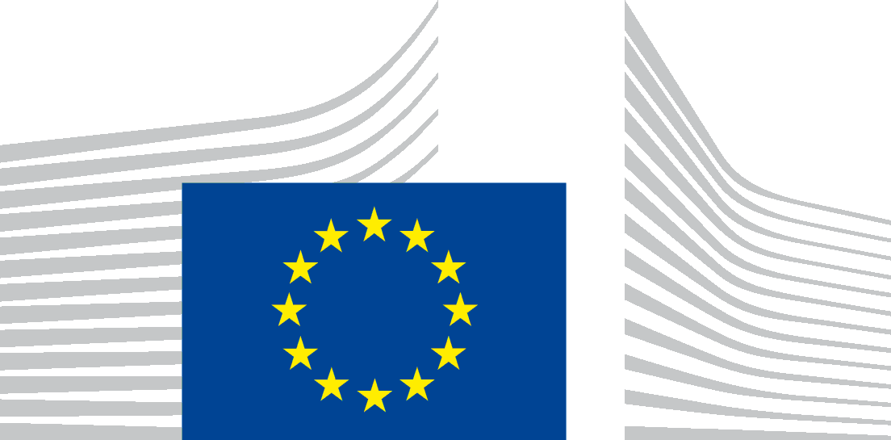 | EUROPEAN COMMISSION

VACANCY NOTICE FOR A POST OF SECONDED NATIONAL EXPERT

DG – Directorate – Unit | EU Delegation to the UN in Geneva
Post number in sysper: | 505343
Contact person:  Provisional starting date:  Initial duration:  Place of secondment: | Michele LOMBARDINI, Damyana STOYNOVA  1 quarter 2026  2 years  ☐ Brussels ☐ Luxemburg ☒ Other: EU Delegation to the UN and Other Internationl Organisations in Geneva
Type of secondment
This vacancy notice is open to:
as well as
☐ The following EFTA countries:
☐ Iceland ☐ Liechtenstein ☐ Norway ☐ Switzerland
☐ The following third countries: ….
☐ The following intergovernmental organisations: …

Deadline for applications | Latest application date: Click or tap to enter a date.

Entity Presentation (We are)

We are the Economic Team of the EU Delegation to the United Nations and Other International Organisations in Geneva, covering a range of different issues including Digital, Trade and Development, Intellectual Property Rights, Economic Integration, Climate and Environment.

Job Presentation (We propose)

Global Gateway is the European Union’s strategy to boost smart, clean and secure connections in digital, energy and transport sectors, and to strengthen health, education and research systems across the world. The Seconded National Expert / Policy Officer will work in the Economic Section of the EU Delegation in Geneva, acting as the focal point for digital infrastructure and human centric digital transformation. The post covers a broad range of Global Gateway digital and technology-related issues across the UN system and other international organisations based in Geneva, including UNCTAD, ITU, WIPO, UNECE. The SNE will support the EU Delegation in formulating, coordinating, and presenting EU policy and programmes on digital policy, artificial intelligence, data governance, connectivity, and related matters, ensuring coherence with broader EU digital, trade, and development objectives as well as boosting public-private partnerships.
The SNE will work closely with colleagues across sections of the Delegation and Multilateral Geneva to ensure that digital issues are addressed in a consistent and strategic manner across the UN system. The SNE will also engage with non-state actors, including private sector representatives, academia, and civil society.

The SNE will work under the supervision of the Head of Section. Without prejudice to the principle of loyal cooperation between the national/regional and European administrations, the SNE will not work on individual cases with implications for files he/she would have had to deal with in his/her national administration in the two years preceding its entry into the Commission, or directly adjacent cases. In no case he/she shall represent the Commission in order to make commitments, financial or otherwise.

Functions and duties

+ POLICY DEVELOPMENT – Policy and programme advice
- Act as Delegation focal point for Global Gateway / digital issues and provide advice across the UN and other Geneva-based organisations and to Headquarters.
- Engage ITU, UNCTAD, CSTD (Commission on Science and Technology for Development), and other relevant entities on Global Gateway and digital policy matters.
- Support EU Delegations and services to design and implement programmes, initiatives and projects in line with the Global Gateway priorities and the external dimension of EU digital infrastructure and connectivity policies.

+ POLICY DEVELOPMENT – Monitoring and reporting
- Monitor, analyse and report back on developments regarding Global Gateway digital-related issues to Commission HQ and EEAS.
- Draft briefings, background notes, and analytical reports for Commission HQ on key developments and negotiations.
- Contribute to outreach events and public diplomacy activities to promote Global Gateway and strengthen partnerships.

+ REPRESENTATION, NEGOTIATION and PARTICIPATION – Working relations & negotiations
- Coordinate with the Commission, the EEAS and Team Europe, and engage the private sector and civil society on digital issues.
- Maintain close relationships with Geneva-based EU Member State representatives and convene and chair regular local coordination meetings.
- Represent the EU Delegation in meetings of relevant UN bodies and international organisations dealing with Global Gateway, digital, AI, and technology matters.
- Influence third countries on major digital processes, including the Global Digital Compact, WSIS+20, Internet Governance Forum, and related initiatives.

Jobholder Profile (We look for)

Experience
At least 5 years of relevant experience.
- Good knowledge of the EU digital infrastructure and connectivity policies and programmes, including space-based connectivity.
- Experience of working in an international context and with EU Delegations and international organisations.
- Experience of negotiating with a large variety of stakeholders.
- Excellent analytical and drafting skills as well as capability to present complex and technical policy issues.
- Excellent communication skills, allowing for effective engagement of all counterparts, Member states, International Organisations, International Finance Institutions, partner countries, and other stakeholders.
- Strong inter-personal skills.
- Resilience to stress and availability to cope with peaks of work.

Languages
- The position requires written and oral fluency in English. Good knowledge of French would be an asset.

Knowledge
We are looking for a creative colleague with a solutions-orientated attitude, the ability to anticipate problems, solid drafting, analytical and negotiation skills, a strong sense of initiative and organisation as well as the capacity to work both independently and in a team. The candidate shall demonstrate that she/he is particularly able to build constructive relationships and extensive networks within the EU and with multilateral stakeholders.

Job related issues
[x] Atypical working hours

Comments:
Representation and coordination duties in the UN bodies often require work beyond regular office hours, and sometimes on weekends.

Eligibility criteria

The secondment will be governed by the Commission Decision C(2008) 6866 of 12/11/2008 laying down rules on the secondment to the Commission of national experts and national experts in professional training (SNE Decision).

Under the terms of the SNE Decision, you need to comply with the following eligibility criteria at the starting date of the secondment:
- Professional experience: at least five years of professional experience in administrative, legal, scientific, technical, advisory or supervisory functions which are equivalent to those of function group AD.
- Seniority: having worked for at least 2 full years (24 months) with your current employer on a permanent or contract basis.
- Employer: must be a national, regional or local administration or an intergovernmental public organisation (IGO); exceptionally and following a specific derogation, the Commission may accept applications where your employer is a public sector body (e.g., an agency or regulatory institute), university or independent research institute.
- Linguistic skills: thorough knowledge of one of the EU languages and a satisfactory knowledge of another EU language to the extent necessary for the performance of the duties. If you come from a third country, you must produce evidence of a thorough knowledge of the EU language necessary for the performance of his duties.

Conditions of secondment

During the full duration of your secondment, you must remain employed and remunerated by your employer and covered by your (national) social security system.
You shall exercise your duties within the Commission under the conditions as set out by aforementioned SNE Decision and be subject to the rules on confidentiality, loyalty and absence of conflict of interest as defined therein.
In case the position is published with allowances, these can only be granted when you fulfil the conditions provided for in Article 17 of the SNE decision.
Staff posted in a European Union Delegation are required to have a security clearance (up to SECRET UE/EU SECRET level according to Commission Decision (EU, Euratom) 2015/444 of 13 March 2015. It is up to you to launch the vetting procedure before getting the secondment confirmation.

Submission of applications and selection procedure

If you are interested, please follow the instructions given by your employer on how to apply.
The European Commission only accepts applications which have been submitted through the Permanent Representation / Diplomatic Mission to the EU of your country, the EFTA Secretariat or through the channel(s) it has specifically agreed to. Applications received directly from you or your employer will not be taken into consideration.
You should draft you CV in English, French or German using the Europass CV format (Create your Europass CV | Europass). It must mention your nationality.
Please do not add any other documents (such as copy of passport, copy of degrees or certificate of professional experience, etc.). If necessary, these will be requested at a later stage.

Processing of personal data

The Commission will ensure that candidates’ personal data are processed as required by Regulation (EU) 2018/1725 of the European Parliament and of the Council (). This applies in particular to the confidentiality and security of such data. Before applying, please read the attached privacy statement.

() Regulation (EU) 2018/1725 of the European Parliament and of the Council of 23 October 2018 on the protection of natural persons with regard to the processing of personal data by the Union institutions, bodies, offices and agencies and on the free movement of such data, and repealing Regulation (EC) No 45/2001 and Decision No 1247/2002/EC (OJ L 295, 21.11.2018, p. 39

